**Response 1**

Search Engine Optimization (SEO) is important if you want to get your website noticed. With the right key words your website can be found by others looking for your services. to effectively benefit from SEO, you need to consider which tactics will provide you with the highest ROI and are also completely aligned with search engine regulations and rules. Black-hat SEO tactics, which aren't geared towards a legitimate user audience and are more focused for search engines, will get you penalized with Google, and likely result in your organization being removed from search results altogether. "One way to help your brand come up with web content that provides value is by using Google's auto fill feature. Auto fill is the list of search queries that Google predicts and lists for you when you type in a keyword. It's a helpful feature to save people time, and it's also great for marketers who need content ideas. Here's how:

1. Get a list of keywords you want to rank for.
2. Enter it into the Google search bar.
3. Then add a letter of the alphabet. For example, type "online marketing" + "a" and you'll see a list of search queries where the next word starts with the letter "a."
4. Write down the suggested search queries that might be good to create content around. Even if you aren't sure you're going to write about these topics, record them anyway. You want to create a big list to reference whenever you run out of content ideas.

he **title tag** is the most important element on any web page. If you do a ‘Control + U’ on any page, you’ll see the title tag in source code. It’s bounded by title tags.

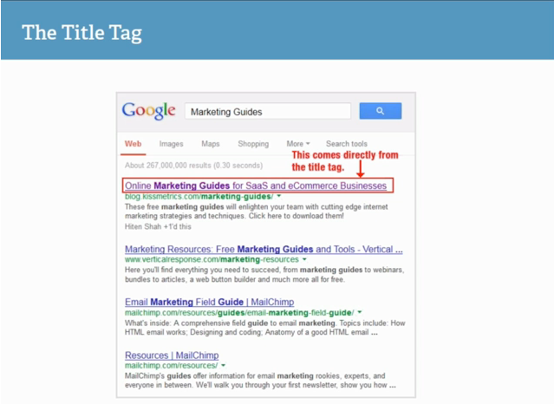

You want to make sure you only have one title tag per page. What you put in the title tag is basically how Google decides what’s going to be in search engine results.

<https://neilpatel.com/blog/website-source-code-seo/>

**Response 2**

With search engine optimization, it is important to write and publish excellent content that your user base would be interested in. Not having good content can be a problem when it is time to check the rankings of your websites articles. Everything must be well written and easily to understand. Your content can be ranked higher if your site has a lot of activity and everyone is engaged with writing comments and viewing your videos.

Another key is to use keywords to see what people are searching and if the demand is high, your rankings will also grow. The amount of traffic your site receives is vital when it comes to search engine optimization.

Also, social media nowadays plans a big roll in social media optimization. Twitter is a good tool to use to build relationships with your users and instagram is a huge platform for traffic also.

Mobile friendly websites are another key here with most people now using their mobile devices in place of personal computers. Think outside the box and don’t limit yourself to just one to. Rely on what’s available and use it to your advantage

**Response 3**

Make sure that you use a unique domain name so that way as viewer are looking for key words they are able to find your website. Sometimes it is hard to come out with a unique domain name because a lot of them already taken by somebody else. You have to be creative, you can also check out different domain name registrars like godaddy.com to check to see if the domain name is already taken. Another thing that you have to consider as a small business or small website is the type of web hosting. This needs to be the correct one for your website consideration like what operating system, what is the bandwidth and technical support are just a few things that you need to pay attention as this will provide the viewer a better experience when they visit your website. Using a search engine can also help you with optimizing of your website as this is the most popular way of how people browse for services online. Some of the things that you include in your code to improve your website could be page titles <title> tags, make sure that your heading tags are also aligned <h1>, <h2> and so on. You might also want to think about a good description about your website so the way it will give the viewers a quick description about the website.

**Response 4**

Having a search engine Optimization is a very great to have for your website because the website will increase the opportunity to rank the highest in the main keywords, which will give you the most traffic on the website. For example, if your eCommerce business is not getting people to buy or to look at your website, by having search engine you will go global.

HTML is the basic code for the creating a web pages and by having a search engines you can chance the ranking communication from the certain HTML elements.

So, my suggestion will be if you don't have search engines on your website you should get the search engines to enhance your business to grow. For a fact, all you have to do is type the same of the store on search engine and people all over the world is see your company.

**Response 5**

Hello Everyone,

Search Engine Optimization (SEO) is critical to any successful website. Therefore, it is critical that developers learn how search engines work and what criteria they look at to rank sites. The main purpose of the crawlers for most major search engines is to rank sites according to relevancy. That is, they look for the sites that pertain to the search terms entered into the search engine.

There are several ways in which developers can ensure their sites rank highly in the rankings. For example, the more relevant websites that link to a site, the better it may rank. Additionally, crawlers can index sites better if a sitemap is included for the website. Therefore, it is important for developers to include one. Also, developers should enter relevant titles within the title tags of a site because those also speak to relevance. Website builders should also make sure their headings match the content within their site. Finally, developers should ensure their content contains the same terms for which they would like to be found in the search engines. However, they must not overdo it with these terms because the search engines could see it as what’s called spamming the search engines, which could result in a site not being indexed.

**Response 6**

When trying to improve your sites SEO or search engine optimization you first have to understand what SEO is and how its works exactly. Based on https://searchengineland.com All major search engines such as Google, Bing and Yahoo have primary search results, where web pages and other content such as videos or local listings are shown and ranked based on what the search engine considers most relevant to users. Payment isn’t involved, as it is with paid search ads. there are certain tools that you can use to optimize your website some of these tools include Google search console, SEMrush, Buzzstream, MOZ pro, and Linkody. This is not a full list of the tools that are available but they are all a good example of what can be used to increase your search engine ranking. All of these tools use various methods such as data that enables you to research both specific long-tail keywords and other domains. You can use this information to avoid keywords with little potential and to improve on what your competitors are doing. Or for instance the Google search console that uses a collection of services that you can use to figure out how the search engine views your website. This service provides you with a wide array of tools to use, covering many different aspects of SEO.

**Response 7**

Search Engine Optimization is important in the development of your website because it increases your visibility among the common user browsing the web in search of maybe something your website has to offer. First and foremost, you need to make sure your website is in various search engines indexes. You can do this by going to the search engines and searching your website URL. If you're not there it can because the compatibility of your site with other pages, the design doesn't allow the search engine to crawl your content, your websites policies block the search engine, or it can be as simple as your website is relatively new and hasn't been crawled yet. Either way, you should ensure any issues is resolved so that you appear on all indexes. Another tip is to make your titles unique. You also do not want it to be too complicated. You want it to describe exactly what the user should expect on your site. It is extremely important to correctly, and effectively, use HTML tags in the right parts of your code.

For example, Including a good description in your header will allow someone browsing a search engine a brief explanation of what your page has to offer. You want to try and reel them in.

<meta name="description=" content="CubsFans.Net is your go to site for all things Chicago Cubs. We provide an in depth look at the best team in the MLB.">